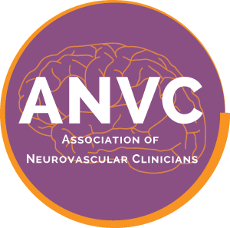

Association of Neurovascular Clinicians Certification Program
Please do not leave any section unanswered or your application may be denied.

I am applying for the examination certification of Advanced Neurovascular Practitioner (ANVP-BC)

Name as you wish it to appear on the certificate:

Credentials:

Home Mailing Address:

City: State: Zip Code:

E-mail: Daytime Phone:

Completed a curriculum-based formal academic fellowship in acute neurovascular/stroke? YES NO
If YES, please complete the following:
Name of Fellowship Program:
Fellowship Director name:
Program Mailing Address:
City: State: Zip Code:
Fellowship Director’s Daytime Phone: E-mail:

If NO, please complete the following:
Name of Physician Supervisor Verifying > 5 Years-Experience Employed as an Acute Stroke APP:
Physician Supervisor’s Mailing Address:
City: State: Zip Code:
Physician Supervisor’s Daytime Phone: E-mail:
Name of Hospital Administrator Verifying > 5 Years-Experience Employed as an Acute Stroke APP:
Hospital Administrator’s Mailing Address:
City: State: Zip Code:
Hospital Administrator’s Daytime Phone: E-mail:

By initialing this box, I am providing my electronic signature affirming that all the information entered above is accurate and complete. I attest that I have been directly involved (≥ 1,000 hrs) in the care of neurovascular patients, or in management, education or research directly related to neurovascular care as a clinician (RN, APRN, CNS, PA) during the past ONE (1) year. I further affirm that I am currently licensed to practice in the state of ,
License # , and prepared to provide work hour documentation if my application is audited. I further affirm that no licensing authority has taken any disciplinary action in relation to my license to practice in the aforementioned or any other state, and that my license to practice has not been suspended or revoked by any state or jurisdiction.
I authorize ANVC permission to contact my Neurovascular Fellowship Director, or my Physician Supervisor or Hospital Administrator to verify Neurovascular fellowship program completion or that I have attained at least 5 years work experience as an APP in the care of acute neurovascular patients.
I give ANVC permission to publish my name, credentials, and place of employment on the website
By signing, I authorize ANVC permission to contact my Neurovascular Fellowship Director to verify Neurovascular fellowship program completion.
Date
Signa-ture

