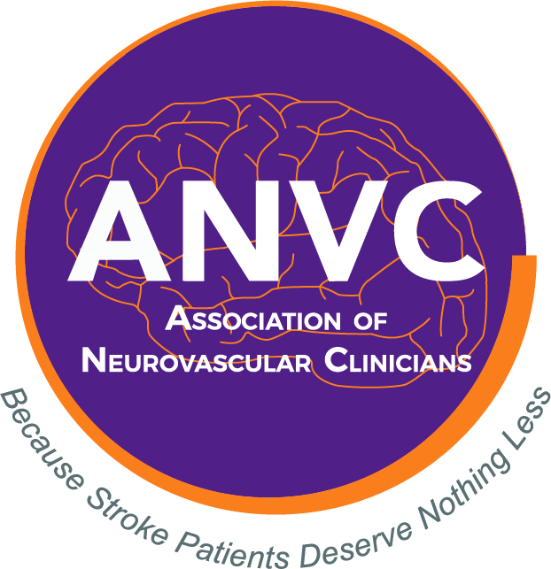

Association of Neurovascular Clinicians Certification Program
Please do not leave any section unanswered or your application may be denied.

I am applying for the examination certification of Advanced Stroke Coordinator (ASC-BC)

Name as you wish it to appear on the certificate:

Title: Credentials:

Home Mailing Address:

City: State: Zip Code:

Daytime Phone: E-mail:

Supervisor name:

Supervisor Title:

Supervisor Email Address:

Place of Employment:

Employment Mailing Address:

City: State: Zip Code:

Daytime Phone:

By initialing this box, I am providing my electronic signature affirming that all the information entered above is accurate and complete. I further affirm that I am currently licensed to practice as a nurse in the state of License # (this is not a requirement – however if you wish to receive nursing CEUs – please provide). I agree to release this application page for audit/employment verification purposes. I agree to give ANVC permission to publish my name, credentials, and place of employment on the website.
Date
Signature

