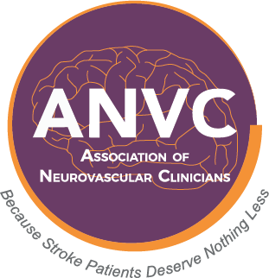

Association of Neurovascular Clinicians Certification Program
Please do not leave any section unanswered or your application may be denied.

I am applying for the examination certification of Advanced Neurovascular Practitioner (ANVP-BC)

Name as you wish it to appear on the certificate: _____________________________

Credentials: ____________________________________________________________

Home Mailing Address: ___________________________________________________

City: ______ ______ State: ______ Zip Code: _________

E-mail: ___________________ Daytime Phone: __________

Fellowship Director name: _______________________________

Fellowship Director Mailing Address: ________________________________________

City: ___________ State: ___________ Zip Code: ________

Fellowship Director Daytime Phone: _____________________

Fellowship Director E-mail: _______________________________________________

__ | - By initialing this box, I am providing my electronic signature affirming that all the information entered above is accurate and complete.  - I attest that I have been directly involved (≥ 1,000 hours) in the care of neurovascular patients, or in management, education or research directly related to neurovascular care as a clinician (RN, APRN, CNS, PA) during the past ONE (1) year.  - I have completed a post-graduate (post Master’s degree) acute neurovascular fellowship or am an Advanced Practice Provider (APP) with a minimum of an earned Master’s degree that lacks acute neurovascular fellowship training but have a minimum of 5 years acute stroke work experience as an APP.  - I further affirm that I am currently licensed to practice in the state of _________, License # __________, and prepared to provide work hour documentation if my application is audited.  - I further affirm that no licensing authority has taken any disciplinary action in relation to my license to practice in the aforementioned or any other state, and that my license to practice has not been suspended or revoked by any state or jurisdiction.  - I authorize ANVC permission to contact my Neurovascular Fellowship Director to verify Neurovascular fellowship program completion.  - I give ANVC permission to publish my name, credentials, and place of employment on the website
LS | By signing, I authorize ANVC permission to contact my Neurovascular Fellowship Director to verify Neurovascular fellowship program completion.
Date | __________
Signa-ture | ______________

