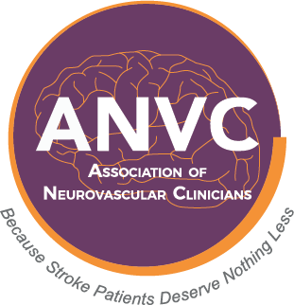

Association of Neurovascular Clinicians Certification Program
Please do not leave any section unanswered or your application may be denied.

I am applying for the examination certification of Certified Neurointerventional Clinician (CNIC-BC).

Name as you wish it to appear on the certificate:

Title: Credentials:

Home Mailing Address:

City: State: Zip Code:

Daytime Phone: E-mail:

Supervisor Name:

Supervisor Title:

Supervisor Email Address:

Place of Employment:

Employment Mailing Address:

City: State: Zip Code:

Daytime Phone:

By initialing this box, I am providing my electronic signature affirming that all the information entered above is accurate and complete. I attest that I have been directly involved (≥ 1,000 hrs. in the past 12 months) in the clinical care of patients undergoing interventional catheterization procedures (neurovascular or cardiovascular), OR the clinical care of acute stroke patients, and am a licensed provider (RN, NP, CNS, PA, RT, or EMT-P) in the state/territory/country of , License # and/or hold current ARRT or other international RT certified provider, Certification # . I am prepared to provide work hour documentation and copies of my current certification and/or licensure if my application is audited. I further affirm that no licensing authority has taken any disciplinary action in relation to my license to practice in the aforementioned or any other location, and that my license to practice has not been suspended or revoked by any state or jurisdiction. I agree to release this application page for audit/employment verification purposes. I agree to give ANVC permission to publish my name, credentials, and place of employment on the website.
Date
Signature

