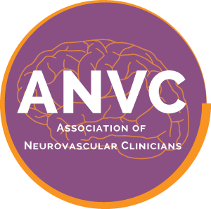

Association of Neurovascular Clinicians Certification Program
Please do not leave any section unanswered or your application may be denied.

I am applying for the examination certification of Neurovascular Registered Nurse (NVRN-BC)

Name as you wish it to appear on the certificate:

Title: Credentials:

Home Mailing Address:

City: State: Zip Code:

Daytime Phone: E-mail:

Supervisor name:

Title:

Place of Employment:

Mailing Address:

City: State: Zip Code:

Daytime Phone: E-mail:

By initialing this box, I am providing my electronic signature affirming that all the information entered above is accurate and complete. I attest that I have been directly involved (≥ 1,000 hrs) in the care of neurovascular patients, or in management, education or research directly related to neurovascular care as a clinician (RN, NP, CNS, PA) during the past ONE (1) year. I further affirm that I am currently licensed to practice in the state of License # , and prepared to provide work hour documentation if my application is audited. I further affirm that no licensing authority has taken any disciplinary action in relation to my license to practice in the aforementioned or any other state, and that my license to practice has not been suspended or revoked by any state or jurisdiction. I agree to release this application page for audit/employment verification purposes. I agree to give ANVC permission to publish my name, credentials, and place of employment on the website.
Date
Signature

